kl/ro / k[i7e'dL:
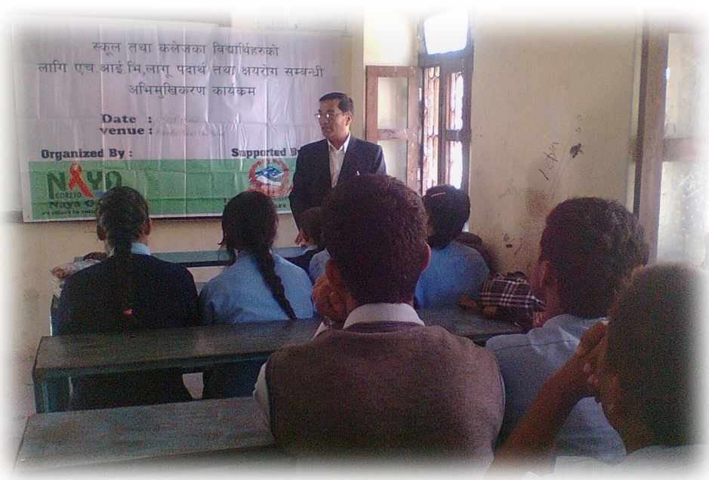
;g\ !(#% df ljZj :jf:Yo ;+u7gn] nfu" kbfy{ ;]jg ug{'nfO{ dgf] efjdf k|efj kfg]{ /f]u elg k|dfl0ft ul/;s]sf] cj:yfdf klg g]kfn h:tf] ljsf;f]Gd'v b]zdf nfu" kbfy{ ;]jg ug{'nfO{ /f]u / nfu"kbfy{ ;]jgstf{nfO{ Ps k|sf/sf] /f]uL elg ;xh ?kdf :jLsfg{ ;s]sf] 5}g . o;/L nfu" kbfy{ k|of]ustf{x?nfO{ /f]uL elg :jLsfg{ g;Sbf plrt k/fdz{, cfjZostf cg'?k ;xof]u / pkrf/ ;dodf g} pknAw gug{' / clxn];Dd klg ck/fwL elg kl/eflift ugf{n] ;dfhdf o'jf ju{, ljBfno÷sn]hsf ljBfyL{x? lbg k|ltlbg nfu" kbfy{ k|of]usf] bnbndf emg emg km:b} uPsf] 5 . o'jf ju{, ljBfno÷sn]hsf ljBfyL{x?nfO{ nfu" kbfy{ ;DaGwL plrt 1fg, lzIffsf] cefj / cleefjsx?sf] x's{+b} u/]sf] 5f]/f5f]/L k|ltsf] cleefjlso e'ldsfsf] 1fgsf] sdL÷x]nr]qmfO{sf sf/0fn] klg o'jf ;d"x, ljBfyL{x? nfu" kbfy{sf] b'Ao{zgsf] lzsf/ eO{ c;'/lIft nfu" kbfy{ ;]jg / c;'/lIft of}g Aojxf/sf] sf/0f Pr=cfO{=eL, x]kf6fOl6;\ nufot cGo y'k|} /uthGo ;+qmd0fsf] hf]lvd a9b} hfgfn] b]zsf] lhDd]jf/ / pTkfbglzn ;d"x nfu" kbfy{sf] e'd/Ldf kl/ b]zs} cfly{s pGgltdf ;d]t ulx/f] c;/ k/]sf] 5 .

cem ;/sf/sf] plrt / :ki6 gLlt lgodsf] cefjdf nfu" kbfy{ k|of]ustf{x?nfO{ :yflgo k|x/L k|zf;g / ;d'bfon] ul/g] dfgl;s Pj+d zfl/l/s oftgf, ;dfg :jf:Yo pkrf/jf6 jl~rt ugf{n] nfu" kbfy{ k|of]ustf{x? nfu" kbfy{sf] bnbnjf6 plDsg ;ls/x]sf] 5}g . h;n] ubf{ pTkfbgzLn o'jf ;d"x nfu" kbfy{ b'Ao;{gsf sf/0f jf6f] lj/fO{ o'jf zlQm, l;k, >d b]z ljsf;sf nflu vlr{gjf6 jl~rt x'Fbf b]zsf] cfly{s, ef}lts kIfdf ;d]t gsf/fTds c;/ k'u]sf] 5 . ;dodf g} ;/sf/, ;/f]sf/jfnf ;+3–;+:yf, ;d'bfo, cleefjsn] of] ;d:ofnfO{ ;dfwfgsf nflu kxn gug]{ xf] eg] o'jf, ljBfyL{x? nfu" kbfy{ k|of]ustf{x? emg emg a9\b} hfg]5 eg] csf]{lt/ ;d'bfodf Pr=cfO{=eL=, x]kf6fOl6; h:tf /uthGo ;+qmd0fsf] b/ klg a9\b} hfg]5 . t;y{ of] a9b} uPsf] ;d:ofnfO{ Wofgdf /flv :s"n tyf sn]hsf ljBfyL{x?nfO{ nfu" kbfy{ ;]jg ug{jf6 /f]Sg, nfu" kbfy{ k|of]usf sf/0f x'g] IfltnfO{ Go'lgs/0f ug{, nfu" kbfy{ k|of]u ul//x]sf ;d"xnfO{ plrt pkrf/ k|bfg ug{, ;d'bfodf Pr=cfO{=eL+, x]kf6fOl6; h:tf /uthGo ;+qmd0f b/nfO{ Go'g ug{ nlntk'/ pk–dxfgu/kflnsfsf] cfly{s ;xof]udf gofF uf]/]6f] / nlntk'/ nfu" kbfy{ k|of]ustf{x?sf] nflu jsfnlto ;~hfnn] k"j{ nfu" kbfy{ k|of]ustf{ :jo+ ;]jsx?nfO{ g} kl/rfng ul/ nlnk'/ lhNnfsf :s"n÷sn]hsf ljBfyL{x?nfO{ nfu" kbfy{ / Pr=cfO{=eL ljifos cled'lvs/0f / ;r]tgfTds sfo{qmd ;~rfng ug{ nlntk'/ pk–dxfgu/kflnsf;+u ;Demf}tf ul/of] .

sfo{qmd ;~rfng:
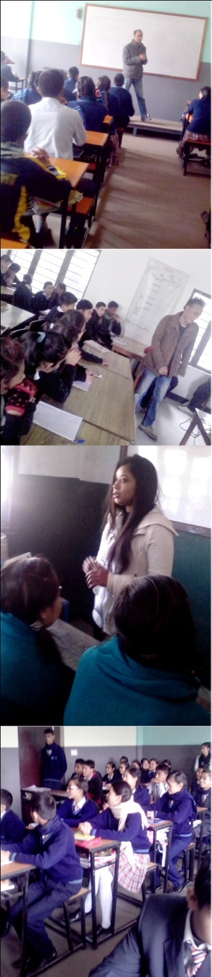
nlntk'/ pk–dxfgu/kflnsfsf $@ :s"n tyf sn]hsf k|fwfgfWofks, ;+of]hs;+u ;xsfo{ u/L dfWoflds / pRr dfWoflds txsf ljBfyL{x?nfO{ nfu" kbfy{sf] a9\bf] k|of]u / o;sf] c;/ tyf Pr=cfO{=eL= ljifos cGt/lqmof tyf cled'lvs/0f sfo{qmd @)&! ;fn d+l;/ !% ut] ;dfh sNof0f dxfzfvf, nlntk'/ pk–dxfgu/kflnsfsf jl/i7 clws[t >L czf]s >]i7 Ho"jf6 pb\3f6g ul/ ;'? ul/of] . pb\3f6gdf >L czf]s >]i7 Ho"n] af]Ng' x'Fb} cfhsf] cj:yfdf :s"n tyf sn]hsf ljBfyL{x? nfu" kbfy{ ;]jgsf] bnbndf km:b} hfg'sf] Pp6f k|d'v sf/0f :s"n÷sn]hdf nfu" kbfy{ / Pr=cfO{=eL= ljifodf plrt lzIff k|jfx gx'g' / x's{+b} u/]sf] 5f]/f5f]/Lx? k|lt cleefjsn] ;lx 9Ën] lhDd]jf/L k"/f gug{' klg xf] egL k|i6\ofpg' eof] t;y{ :s"n÷sn]hdf k9\g] ljBfyL{x? nfu" kbfy{ k|of]u ug{jf6 s;/L /f]Sg ;S5, nfu" kbfy{ k|of]usf sf/0f x'g] ;fdflhs / AolQmut c;/ af/] atfpg'sf] ;fy} nfu" kbfy{ k|of]ustf{x?nfO{ pkrf/ u/fO{ ;fdflhs lqmofsnfk, ljsf;÷lgdf{0fsf sfo{qmd tyf cGo ultljlwx?df ;lDdlnt x'g] cj;/ k|bfg u/] nfu" kbfy{ k|of]ustf{x?n] klg k|efjsf/L of]ubfg lbg ;Sg] ePsf]n] cfTdf ;Ddfgsf ;fy AffRg k|]/0ff lbg' klg sfo{qmsf] p2]Zo ePsf] :ki6 kfg{' eof] .

sfo{qmd lj:t[t:
gofF uf]/]6f] / nlntk'/ nfu"kbfy{ k|of]ustf{x?sf] nflu jsfnlto ;+hfnsf] k"j{ nfu" kbfy{ k|of]ustf{ :jo+;]ljx?nfO{ >f]t AolQmsf] ?kdf kl/rfng u/L nlntk'/ pk–dxfgu/kflnsf leqsf ljleGg :s'n÷ sn]hsf ljBfyL{x? nfu" kbfy{sf] k|of]usf] /f]syfd, nfu" kbfy{ k|of]usf sf/0f x'g] xfgL, gf]S;fgL, Iflt / ;fy} Pr=cfO{=eL=÷P8\;sf] /f]syfd af/] ;r]tgfd'ns cled'lvs/0f sfo{qmd ;~rfng ul/of] . sfo{qmddf nfu" kbfy{, Pr=cfO{=eL= / P8\; ;DaGwL j[Qlrq, rf6{ k]k/ tyf cGo k|:t'tLsf ;fdu|L k|of]u u/L efif0f dfk{mt cfjZos hfgsf/L k|bfg u/L cGt/s[ofTds lqmofsnfkjf6 nfu" kbfy{, Pr=cfO{=eL= ;DaGwL ljBfyL{x?sf] lh1f;f, v'Nb'nL, k|Zgx?sf] hjfkm lbO{ gsf/fTds ;f]r kl/jt{g ul/of] . h;n] ubf{ :s"n÷sn]hsf ljBfyL{x?df a9\b} uPsf] nfu" kbfy{ k|of]usf] /f]syfd tyf lgoGq0fsf] r'gf}tL / o;af6 x'g;Sg] Pr=cfO{=eL=sf] hf]lvdaf/] ;r]t u/fO{of] eg] lzIfs lzlIfsfn] klg cfˆgf] ljBfyL{x? k|lt cln lhDd]jf/L eO{ Aojxf/x? s] s:tf] 5 eGg] ;dodf g} Wofg lbg] xf] eg] w]/}xb;Dd ljBfyL{x?nfO{ nfu" kbfy{sf] bnbndf km:gjf6 arfpg ;lsG5 ;fy}nfu" kbfy{jf6 6f9f /xg] pkfox? nufot nfu" kbfy{ ;]jg h:tf /f]udf km;]sfx?nfO{ lbg'kg]{ pkrf/sf pkfox? af/] :ki6 kfl/g'sf] ;fy} nfu" kbfy{ k|of]usf sf/0f ;dfhjf6 x]l/g] x]o tyf e]befjk"0f{ b[li6sf]0fnfO{ Go"g / cGTo ub}{ ;dfhdf ltgLx?nfO{ klg cGo ;fdfGo dflg;x? ;/x ;dfhsf] dxTjk"0f{ ;b:osf] ?kdf k"g;:yflkt ug{ ;a} kIfsf] dxTjk"0f{ e'ldsf /xg] hfgsf/L u/fOof] . nlntk'/ nfu" kbfy{ k|of]ustf{x?sf] nflu jsfnlto ;~hfnsf :jo++;]jL-nfu" kbfy{ k|of]ustf{x?_ Hff] cfk'm klg nfu" kbfy{ b'Jo{;gdf kml; nfu" kbfy{sf] bnbnjf6 6f9f /xg u/]sf k|of;x?sf] cg'ejx? ljBfyL{dfem k|i6\ofpFbf nfu" kbfy{ k|of]ustf{n] klg ;/–;Nnfx / ;xof]u kfP ;fdflhs sfo{ ug{ ;S5 eGg] HjnGt pbfx/0fsf] ?kdf lnP . kl/jf/, ;d'bfo / ;fyLx?sf] ;xof]ufTds ;f]r, efjgfn] g} Pp6f nfu" kbfy{ k|of]ustf{nfO{ lhDd]jf/L af]w u/fO{ ;dfhdf k"gM:yfkgf u/L] ;dfhk|lt pQ/bfoL alg cfˆgf] u'd]sf] cfTd;Ddfg tyf :jfledfgnfO{ k"g k|fKt ug{ cj;/ k|bfg u/]sf] 5 / ;fy} ;d'bfojf6 ul/g] ck/fwL ;/xsf] Jojxf/df sdLNofO{ / plrt pkrf/sf] kx'rdf k'¥ofpg ljz]if dbt u/]ssf] 5 .

p2]Zo :
o; sfo{qmdsf] d'Vo p2]Zox? :
- :s"n sn]hsf ljBfyL{x?nfO{ Nffu" kbfy{sf] k|of]u tyf o;af6 x'g;Sg] Pr=cfO{=eL=÷P8\;sf] af/]df hfgsf/L u/fpg',
- ;dfhdf s] s:tf]] nfu" kbfy{sf] k|of]u eO{ /x]sf] 5 ;f] sf] hfgsf/L u/fpg',
- nfu" kbfy{ k|of]ustf{x?sf] cj:yf, Pr=cfO{=eL=÷P8\; / Pr=cfO{=eL= ;+qmldtx?nfO{ ul/g] nf~5gf tyf e]befjk"0f{ Jojxf/df sdL Nofpg' / ;dfhdf nfu" kbfy{ k|of]ustf{sf] :jMcl:tTjsf] ;fy ;Ddfg k"j{s afRg kfpg'kg]{ clwsf/sf] nflu gofF cjwf/0ffsf] ljsf; ug'{,
- nlntk'/ pk–dxfgu/kflnsf leqsf :s"n÷sn]hsf ljBfyL{x? / dlxnf ;d"xnfO{ Nffu"kbfy{, Pr=cfO{=eL=÷ P8\; jf/] ;r]t u/fpg',
- Nffu" kbfy{, Pr=cfO{=eL=÷P8\;sf] If]qdf] cg'ej a6'n]sf nfu" kbfy{ k|of]ustf{ :jo+;]jLx?nfO{ klg ;dfhdf pQ/bfloTj axg ul/ cfˆgf] of]ubfg lbg Pp6f ;xh jftfj/0f >[hgf ug'{,
- N\flntk'/ lhNnfdf gu/kflnsf :t/, j8f :t/af6 nfu" kbfy{, Pr=cfO{=eL=÷P8\;sf] If]qdf] sfo{of]hgf agfO{ sfo{Gjogsf nflu lhDd]jf/Lsf] af]w u/fpg',
- nfu" kbfy{ k|of]u stf{x?nfO{ ;dfhdf k"g :yfkgf ug{ plrt jftfj/0f >[hgf ug'{ /
- Nffu" kbfy{ k|of]ustf{, Pr=cfO{=eL= ;+qmldtx?nfO{ ;r]tgfd"ns sfo{qmdx?df cy{k"0f{ ;xeflutf u/fpg' .

sfo{qmd ;do, :yfg tyf ;xefuLx? :
nfu" kbfy{sf] a9bf] k|of]u / o;sf] c;/ tyf Pr=cfO{=eL= ljifos cGt/lqmof tyf cled'lvs/0f sfo{qmdsf] sfo{ cjlw ldlt @)&! d+l;/ !% ut]b]lv @)&! ;fn kmfu'g !% ;Dddf $@ j6f :s"n÷sn]hdf hDdf !))@ hgf dWo] -$*^ k'?if / %!^ dlxnf_ ljBfyL{x?nfO{ ;r]tgfd"ns cled'lvs/0f ;~rfng u/L ;kmnk"j{s ;DkGg ul/of] .

cled'lvs/0f sfo{qmdsf s]xL kmf]6f]x?
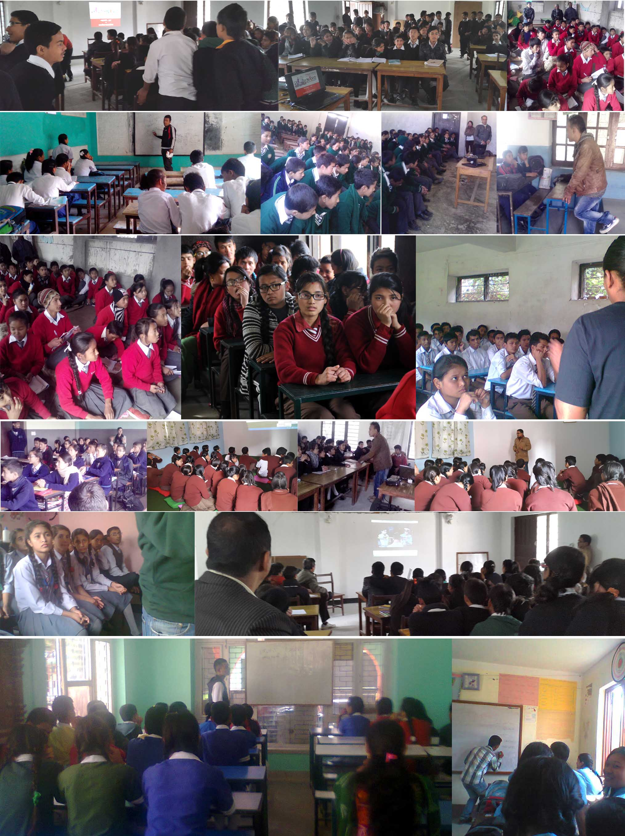

sfo{qmd ;+rfng u/LPsf :s"n÷sn]hdf u/]sf sfo{qmdsf] tflnsf tklzn adf]lhd pNn]v ul/Psf] 5 .

:s"n÷sn]h
S.N. | Date | Venue | No. of Participants |  |  | Volunteers
 |  |  | M | F | Total
1. | 2071/08/15 | Molish Academy  Kumaripati, Lalitpur | 6 | 19 | 25 | Bijay, Shashi, Laxmi Prasad, Manita
2. | 2071/08/15 | Molish Academy, Class  Kumaripati, Lalitpur | 19 | 6 | 25 | Bijay, Shashi, Laxmi Prasad, Manita
3. | 2071/8/18 | Happy House Foundation  Student from different School)  Pulchowk, Lalitpur | 11 | 15 | 26 | Bijay, Shashi, Laxmi Prasad, Manita
4. | 2071/8/18 | Happy House Foundation  Student from different School)  Pulchowk, Lalitpur | 10 | 15 | 25 | Bijay, Shashi, Laxmi Prasad, Manita
5. | 2071/08/25 | Bal Binod Secondary School, Pulchowk, Class – 9 | 7 | 18 | 25 | Bijay, Shashi, Laxmi Prasad, Manita
6. | 2071/08/25 | Bal Binod Secondary School, Pulchowk, Class – 9 | 25 | 0 | 25 | Bijay, Shashi, Laxmi Prasad, Manita
7. | 2071/09/03 | Patan High School, Class – 8  Patan Dhoka | 17 | 8 | 25 | Bijay, Shashi, Laxmi Prasad, Manita
8. | 2071/09/03 | Patan High School, Class – 9  Patan Dhoka | 7 | 18 | 25 | Bijay, Shashi, Laxmi Prasad, Manita
9. | 2071/09/04 | Patan High School, Class – 8 ‘B’  Patan Dhoka | 14 | 12 | 26 | Bijay, Shashi, Laxmi Prasad, Manita
10. | 2071/09/06 | Gyan Bigyan School, Nakhipot, Lalitpur | 14 | 11 | 25 | Bijay, Shashi, Laxmi Prasad, Manita
11. | 2071/09/06 | Gyan Bigyan School, Nakhipot, Lalitpur | 8 | 17 | 25 | Bijay, Shashi, Laxmi Prasad, Manita
12. | 2071/09/07 | Shree Shanti Secondary School, Voldhoka, Lalitpur | 5 | 20 | 25 | Bijay, Shashi, Laxmi Prasad, Manita
13. | 2071/09/08 | Shree Shanti Secondary School,  Voldhoka, Lalitpur | 15 | 10 | 25 | Bijay, Shashi, Laxmi Prasad, Manita
14. | 2071/09/11 | Mahalaxmi Higher Secondary School, Lalitpur | 14 | 11 | 25 | Bijay, Shashi, Laxmi Prasad, Manita
15. | 2071/09/11 | Mahalaxmi Higher Secondary School, Lalitpur | 11 | 14 | 25 | Bijay, Shashi, Laxmi Prasad, Manita
16. | 2071/09/13 | Mahalaxmi Higher Secondary School, Lalitpur | 23 | 2 | 25 | Bijay, Shashi, Laxmi Prasad, Manita
17. | 2071/09/13 | Mahalaxmi Higher Secondary School, Lalitpur | 0 | 22 | 22 | Bijay, Shashi, Laxmi Prasad, Manita
18. | 2071/09/14 | Siddhartha Enghlish School, Sunakothi, Lalitpur | 8 | 17 | 25 | Bijay, Shashi, Laxmi Prasad, Manita
19. | 2071/09/14 | Siddhartha Enghlish School, Sunakothi, Lalitpur | 18 | 7 | 25 | Bijay, Shashi, Laxmi Prasad, Manita
20. | 2071/09/16 | Siddhartha Enghlish School, Sunakothi, Lalitpur | 8 | 17 | 25 | Bijay, Shashi, Laxmi Prasad, Manita
21. | 2071/09/16 | Siddhartha Enghlish School, Sunakothi, Lalitpur | 14 | 11 | 25 | Bijay, Shashi, Laxmi Prasad, Manita
22. | 2071/09/17 | Samajik Yuwa Secondary School, Khokana, Lalitpur | 11 | 14 | 25 | Bijay, Shashi, Laxmi Prasad, Manita
23. | 2071/09/17 | Samajik Yuwa Secondary School, Khokana, Lalitpur | 10 | 15 | 25 | Bijay, Shashi, Laxmi Prasad, Manita
24. | 2071/09/20 | Somang Academy, Sunakothi, Lalitpur | 0 | 21 | 21 | Bijay, Shashi, Laxmi Prasad, Manita
25. | 2071/09/20 | Somang Academy, Sunakothi, Lalitpur | 6 | 19 | 25 | Bijay, Shashi, Laxmi Prasad, Manita
26. | 2071/09/27 | Somang Academy, Sunakothi, Lalitpur | 25 | 0 | 25 | Bijay, Shashi, Laxmi Prasad, Manita
27. | 2071/09/27 | Somang Academy, Sunakothi, Lalitpur | 6 | 19 | 25 | Bijay, Shashi, Laxmi Prasad, Manita
28. | 2071/09/29 | Somang Academy, Sunakothi, Lalitpur | 19 | 2 | 21 | Bijay, Shashi, Laxmi Prasad, Manita
29. | 2071/09/29 | Somang Academy, Sunakothi, Lalitpur | 11 | 4 | 15 | Bijay, Shashi, Laxmi Prasad, Manita
30. | 2071/10/02 | Niharika Public Sechool, Lukhusi, Lalitpur | 10 | 15 | 25 | Bijay, Shashi, Laxmi Prasad, Manita
31. | 2071/10/02 | Niharika Public Sechool, Lukhusi, Lalitpur | 15 | 9 | 24 | Bijay, Shashi, Laxmi Prasad, Manita
32. | 2071/10/04 | Prabhat High School, Lukhusi, Lalitpur | 0 | 25 | 25 | Bijay, Shashi, Laxmi Prasad, Manita
33. | 2071/10/04 | Prabhat High School, Lukhusi, Lalitpur | 6 | 19 | 25 | Bijay, Shashi, Laxmi Prasad, Manita
34. | 2071/10/06 | Prabhat High School, Lukhusi, Lalitpur | 13 | 12 | 25 | Bijay, Shashi, Laxmi Prasad, Manita
36. | 2071/10/06 | Prabhat High School, Lukhusi, Lalitpur | 12 | 13 | 25 | Bijay, Shashi, Laxmi Prasad, Manita
37. | 2071/10/18 | Prabhat High School, Lukhusi, Lalitpur | 18 | 6 | 24 | Bijay, Shashi, Laxmi Prasad, Manita
38. | 2071/10/18 | Prabhat High School, Lukhusi, Lalitpur | 3 | 22 | 25 | Bijay, Shashi, Laxmi Prasad, Manita
39. | 2071/10/19 | Prabhat High School, Lukhusi, Lalitpur | 5 | 19 | 24 | Bijay, Shashi, Laxmi Prasad, Manita
40. | 2071/10/19 | Prabhat High School, Lukhusi, Lalitpur | 23 | 2 | 25 | Bijay, Shashi, Laxmi Prasad, Manita
41. | 2071/10/28 | Prabhat High School, Lukhusi, Lalitpur | 24 | 0 | 24 | Bijay, Shashi, Laxmi Prasad, Manita
42. | 2071/10/28 | Prabhat High School, Lukhusi, Lalitpur | 14 | 10 | 24 | Bijay, Shashi, Laxmi Prasad, Manita
Total |  |  | 486 | 516 | 1001
nlIft ;d"x:
nfu" kbfy{sf] a9\bf] k|of]u / o;sf] c;/ tyf Pr=cfO{=eL= ljifos cGt/lqmof tyf cled'lvs/0f sfo{qmd ;~rngsf nflu nfu" kbfy{ k|of]usf] pRr hf]lvddf /x]sf :s"n÷sn]hsf ljwfyL{x? / pRr hf]lvddf /x]sf] ljBfyL{x?nfO{ nfu" kbfy{sf] bnbndf km:gjf6 arfpg k|d'v e'ldsf÷lhDd]jf/L lgjf{x ug{] nlntk'/ lhNnfsf dlxnf ;d"xnfO{ nlIft ul/Psf] lyof] .

:jod;]jL:
nfu" kbfy{sf] a9\bf] k|of]u / o;sf] c;/ tyf Pr=cfO{=eL= ljifos cGt/lqmof tyf cled'lvs/0f sfo{qmdsf] ;~rfngsf nflu gofF uf]/]6f]sf sd{rf/L Pjd nlntk'/ nfu" kbfy{ k|of]us{tfx?sf] nflu jsfnlto ;~hfnsf k"j{ nfu" kbfy{ k|of]ustf{ :jo+;]jL>f]t JolQmsf] ?kdf kl/rfng ul/Psf] lyof] .
sfo{qmddf ;dfj]z ljifout ;fdu|L
o; ;r]tgfd"ns cled'lvs/0f sfo{qmdn] nfu" kbfy{sf] a9\bf] k|of]u / o;sf] c;/, Pr=cfO=eL=÷ P8\;, sf d'Vot ljifox? ;dfj]z ul/Psf]] lyof] .
Pr=cfO{=eL=/P8\;:
- Pr=cfO{=eL=÷P8\; af/] ;fdfGo kl/ro
- Pr=cfO{=eL=÷P8\; af/]sf] k[i7e'dL Oltxf; / tYofÍ
- zl//sf] k|lt/IffTds k|0ffnL
- Pr=cfO{=eL= nufot /QmhGo ;qmd0f /f]syfd tyf pkrf/
- :j]lR5s k/fdz{ hfFr af/] hfgsf/L

Nffu" kbfy{ / o;sf] b'Jo{;g :
- Nffu" kbfy{ / o;sf] b'Jo{;g af/] hgwf/0ff
- Nffu" kbfy{sf] k|of]usf] sf/0fx?
- Nffu" kbfy{sf] k|of]usf nIf0fx?
- Nffu" kbfy{sf c;/ / kl/0ffdx?
- ljleGg pkrf/ s]Gb|x? af/] hfgsf/L

:s"n÷sn]h / cleefjssf] e'ldsf :
- ljBfyL{x?nfO{ nfu" kbfy{ k|of]ujf6 /f]Sg / Pr=cfO{=eL= ;+qmd0fjf6 arfpg :s"n÷sh]sf] e'ldsf
- x's{+b} u/]sf] o'jf 5f]/f5f]/LnfO{ nfu" kbfy{ k|of]u ug{jf6 /f]Sg / Pr=cfO{=eL= ;+qmd0fjf6 arfpg cleefjssf] e'ldsf

;r]tgfd"ns cled'lvs/0f sfo{qmdsf r'gf}tLx? :
:s"n / sn]hsf ljBfyL{x?df ;r]tgfd"ns sfoqmd ;~rfng cjlwe/ ljleGg tklzn adf]lhdsf r'gf}tLx? ;fdgf ul/Psf] lyof] .
- :s"nx?df kl/Iffsf sf/0f ;do ldnfpg sl7gfO{,
- :s"n tyf sn]hsf ljBfyL{x?nfO{ ;DxfNg sl7gfO{,
- ;dosf] kfjlGb
- ljleGg :s"nx?åf/f :s"nsf] kf7\oqmdeGbf cGo ljifodf ?rL gb]vfpg',
- of]hgf cg';f/sf] ;do glbg' / ;do k]m/abn ul//xg' .

;'emfa
- :s"n÷sn]hdf Pr=cfO{=eL= / /QmhGo ;+qmd0f /f]syfd ljifodf ;r]tgfd"ns cled'lvs/0f sfo{qmd ;~rfng ug{ gu/ :t/, j8f :t/ d} ;fdflhs ljsf;sf] ljifo agfO{ jflif{s sfo{ of]hgfdf lg/Gt/ ?kdf ;dfa]; ul/g' kg]{,
- nfu" kbfy{, Pr=cfO{=eL= / /QmhGo ;+qmd0fsf] /f]syfd, lgoGq0f / pkrf/sf] ljifonfO{ klg hg :jf:Yosf] ljifodf ;dfj]z u/L jflif{s of]hgfsf] to ug{' kg]{,
- nfu" kbfy{, Pr=cfO{=eL= / /QmhGo ;+qmd0fsf] ljifodf ;r]tgfd"ns cled'lvs/0f sfo{qmdx? ljBfyL{x? dfq nlIft gu/L cleefjs ;d"x, o'jf ;d"x, Sna, 6f]n ;'wf/ ;ldtL, k|x/L k|;fzgnfO{ klg nlIft u/L gu/ :tl/o jflif{s of]hgfdf ;dfj]; ul/g' kg]{ .

lgrf]8 :
;du|df ;r]tgfd"ns cled'lvs/0f sfo{qmd k|efjsf/L / ;kmntf k"j{s ;~rfng tyf ;DkGg ul/of] . cled'lvs/0f sfo{qmddf :s"n tyf sn]hsf ljBfyL{x?sf] pRr ;+Vof / pT;fxhgs ?kdf ;xefuL x'g'n] klg of] sfo{qmd k|efjsf/L Pj+ ;kmn ePsf] k|dfl0ft x'G5 . ;Dk"0f{ sfo{qmd ;DkGg ul/Ptf klg :s"n÷sn]hjf6 pknAw u/fPsf] ;do oy]i6 gePsf]n] sfo{qmd ;~rfng ug{ s]xL sl7gfO{ eof] . t;y{ eljiodf :s"n÷sn]h nfu" kbfy{, Pr=cfO{=eL=÷P8\; / /QmhGo ;+qmd0fsf] ljifodf ;r]tgfd"ns sfo{qmd ;~rfng ug{ gu/ kflnsfjf6 g} kqfrf/ u/L oy]i6 ;do dfu ul/lbPsf] v08df sfo{qmdx? cem k|efjsf/L x'g] lyof] . ;dfh sNof0f dxfzfvf, nlntk'/ pk–dxfgu/kflnsfsf jl/i7 clws[t >L czf]s >]i7 Ho"sf] lgl/If0f tyf k|:t'tLn] sfo{qmd cem k|efjsf/L ePsf] lyof] . ;r]gfd"ns cled'lvs/0f sfo{qmddf hDdf !))@ hgf :s"n÷sn]hsf ljBfyL{x?sf] ;xefuLtf lyof] t;y{ cufdL cfly{s jif{x?df klg o; lsl;dsf sfo{qmdx?sf] cToGt dxTj /x]sf] hgfpFb5 . o;tf sfo{qmdx?df k"j{ nfu"kbfy{ k|of]ustf{x? :jo+ ;]js eO{ k|ToIf ?kdf ;+nUg x'gfn] Psflt/ nfu"kbfy{ k|of]ustf{x?sf] cfˆgf] l;ksf] ;b'kof]u ug]{ df}sf kfP eg] csf]{lt/ ;dfhn] nfu" kbfy{ k|of]ustf{, Pr=cfO{=eL= ;+qmldtx?nfO{ x]l/g] b[li6sf]0fdf kl/jt{g ub}{ gofF cjwf/0ffsf] ljsf; ;d]t ug{ ljz]if 6]jf k'u]sf] 5 .

